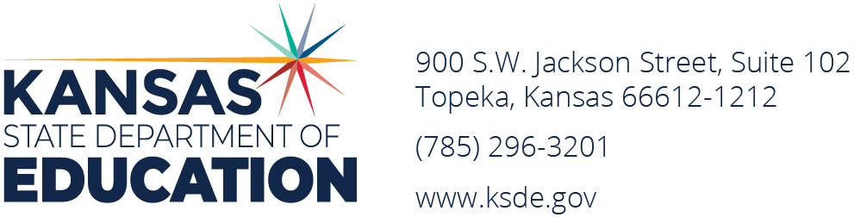

To: Chief School Administrators

From: Frank Harwood, Deputy Commissioner
Division of Fiscal and Administrative Services

Dale Brungardt, Director of School Finance
Shane Carter, Director of Teacher Licensure and Accreditation

Date: April 1, 2025

Subject: Guidelines for National Board for Professional Teaching Standards Certification Incentive Program

A summary of the incentive bonus of $1,000 for the National Board Certified teachers under KSA 72-2166 is as follows:

National Board for Professional Teaching Standards Certification Initiative
A teacher employed by a Kansas school district who has attained National Board certification shall be paid an incentive bonus of $1,000. The bonus is paid each school year as long as the teacher remains employed by a Kansas school district in an appropriate teaching assignment and retains a valid master teacher's certificate. The bonus is paid by the employing school district, but this year the school district is entitled to receive state aid under the National Board for Professional Teaching Standards Certification Incentive Program equal to the amount of any bonuses paid up to $1,000. The state aid is deposited in the school district general fund and is treated as a reimbursement.

The complete text from KSA 72-2166 for this incentive program is on page 2 of this memo.

The following guidelines have been established for payment of the incentive program:

- April 1 KSDE requests the information on the application form on page 3, including:
1) a list of names of eligible teachers from each school district;
2) the date the National Board Certificate was issued.

- April 28 Reimbursement claim form must be received by School Finance.
Scan application to PDF file and email to Rose Ireland, rosemary.ireland@ksde.gov

- May 15 KSDE will pay each school district $1,000 times the number of eligible National Board Certified
Teachers employed by the district (subject to appropriation)

Additional guidelines include:

1) Teachers employed for part of a year will receive a partial payment.
2) In order to be eligible for the incentive bonus, the teacher must have completed all work
necessary for the National Board Certificate prior to the beginning of the school year (actual
certification may not be until the fall of each year).

3) The state aid payment will be deposited in the general fund and treated as a reimbursement.

You can click on this website NBCT Directory - NBPTS, to search for NBCT Certificate Issue date and Expiration Date.

72-2166. National board for professional teaching standards certification incentive program. (a) The national board for professional teaching standards certification incentive program is hereby established for the purpose of rewarding teachers who have attained certification from the national board. Teachers who have attained certification from the national board shall be issued a master teacher's license by the state board of education. A master teacher's license shall be valid for 10 years and renewable thereafter every 10 years through compliance with continuing education and professional development requirements prescribed by the state board. Teachers who have attained certification from the national board and who are employed by a school district shall be paid an incentive bonus in the amount of $1,000 each school year that the teacher remains employed by a school district and retains a valid master teacher's license.
(b) The board of education of each school district employing one or more national board certified teachers shall pay the incentive bonus to each such teacher in each school year that the teacher retains eligibility for such payment. Each board of education which has made payments of incentive bonuses to national board certified teachers under this subsection may file an application with the state board of education for state aid and shall certify to the state board the amount of such payments. The application and certification shall be on a form prescribed and furnished by the state board, shall contain such information as the state board shall require and shall be filed at the time specified by the state board.
(c) In each school year, each school district employing one or more national board certified teachers is entitled to receive from appropriations for the national board for professional teaching standards certification incentive program an amount which is equal to the amount certified to the state board of education in accordance with the provisions of subsection (b). The state board shall certify to the director of accounts and reports the amount due each school district. The director of accounts and reports shall draw warrants on the state treasurer payable to the treasurer of each school district entitled to payment under this section upon vouchers approved by the state board.
(d) Moneys received by a board of education under this section shall be deposited in the general fund of the school district and shall be considered reimbursements to the district for the purpose of the Kansas school equity and enhancement act, K.S.A. 72-5131 et seq., and amendments thereto, and may be expended whether the same have been budgeted or not.
(e) The state board of education is authorized to provide scholarships of $1,100 each to teachers who are accepted to participate in the national board for professional teaching standards program for initial certification. The state board of education is authorized to provide scholarships of $500 each to teachers who are accepted to participate in the national board for professional teaching standards program for renewal of certification. Any teacher who has been accepted to participate in such program may file an application with the state board of education for a scholarship. The application shall be on a form prescribed and furnished by the state board, shall contain such information as the state board shall require and shall be filed at the time specified by the state board.
(f) As used in this section, the term "school district" means any school district organized and operating under the laws of this state.

History: L. 2000, ch. 138, § 2; L. 2005, ch. 158, § 10; L. 2015, ch. 4, § 30; L. 2017, ch. 95, § 62; July 1.

National Board for Professional Teaching Standards Certification Incentive Program

KANSAS STATE DEPARTMENT OF EDUCATION Application for 2024-2025

SECTION I - Project Review and Approval (to be completed by State Educational Agency)

Signature SEA Official | Approval Date | Approved Amount

SECTION II - District Information
 |  | USD No.
Superintendent |  | USD Name
(area code) telephone number |  | Mailing Address
Contact Person |  | City State Zip

The LEA assures that it will adhere to all fiscal and reporting requirements related to the operation of the National Board for Professional Teaching Standards Certification Incentive Program.

_______________________ __________________________________________________________________________
Date Superintendent's Signature

SECTION III - Criteria

What is the total number of National Board Certified teachers in your district?

Name of Teacher | Educator ID # | Date  NBC Certificate Issued | Was this teacher employed  full time as a class room teacher?  (yes or no) | If no, indicate percent of time employed for  the year.


Program questions: Myra Stithem (Teacher Licensure and Accreditation)
Application questions: Rose Ireland (School Finance)
Fiscal questions: Dale Brungardt or Sara Barnes (785) 296-3872

SUBMIT APPLICATION to KSDE by April 28, 2025.
Email: Rose Ireland at rosemary.ireland@ksde.gov (scan signed application, convert to PDF, attach to email)

National Board for Professional Teaching Standards Certification Incentive Program

KANSAS STATE DEPARTMENT OF EDUCATION Application for 2024-2025

